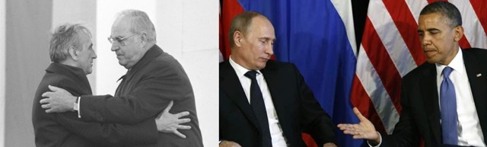

**When Do Reconciliation and Cooperation Matter?**

**Polish-German lessons for the West and Russia**

**Professor Bartosz M. Rydliński**

**Wednesday, Nov. 18th at 3:00-4:00 pm**

**Cuneo Hall 116**

Illegal annexation of the Crimea in 2014 symbolically ended the period of post-Cold War stability in Europe. The war in Eastern Ukraine, which threatens NATO states and the European Union, as well as an unprecedented Russian propaganda campaign have had strongly negative impacts on the current West-Russia relations, which are at their lowest point since the fall of the Soviet Union.

**Bartosz M. Rydliński** is an assistant professor at the Institute of Political Science at the Cardinal Stefan Wyszyński University in Warsaw. Currently Bartosz M. Rydliński is an EASI-Hurford Next Generation Fellow at the Carnegie Endowment for International Peace and expert at the Amicus Europae Foundation of the former Polish president Aleksander Kwaśniewski.

**The talk is sponsored by Polish Studies, European Studies, d 